Lab 6.5: Docker Compose with Centos

This section will show you how to use Docker Compose to manage a container.

This lab has 3 sub-sections:

6.5.1: Build a Dockerfile

6.5.2: Create a docker-compose.yml file

6.5.3: Start the container and exit the container once you have successfully signed in

**Step 6.5.1:** Build a Dockerfile.

Create a Dockerfile.

*touch Dockerfile*

*vi Dockerfile*

Add the content mentioned below in the Dockerfile.

FROM centos:7

RUN yum update -y && yum install httpd httpd-tools -y

EXPOSE 80

#Since services don't run in containers, just applications, we will manually launch httpd in the foreground

CMD ["/usr/sbin/httpd","-D","FOREGROUND"]

Build the Docker image.

*docker build -t "centosapache:0.1" .*

After executing the command above, you should get the result “Successfully built” as shown below.

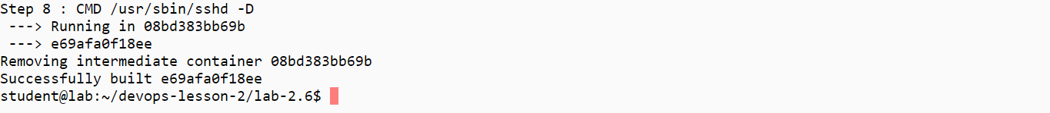

Run the image.

*docker run -d -p 8090:80 --name centoshttpdcontainer centosapache:0.1  
docker ps*

**Step 6.5.2:** Create a docker-compose.yml file.

touch docker-compose.yml

vi docker-compose.yml

Add the content mentioned below in the docker-compose.yml file.

services:

centoshttpd:

image: centosapache:0.1

ports:

- "7080:80"

Look at the Docker Compose YAML file.

*cat docker-compose.yml*

**Step 6.5.3:** Start the server and exit the container once you have successfully signed in.

*~/bin/docker-compose up -d  
~/bin/docker-compose ps*

Connect to the apache web server using your brower on port 7080:

Stop the server.

*~/bin/docker-compose down  
~/bin/docker-compose ps*